Name and Std ID: Wyatt Duberstein 629635057 Lab Section: 19

Date: 10/21/20

**Submission Instructions:**

**Prelab:**

1. **Complete the prelab**
2. **Submit this report with the prelab completed to Canvas before your lab starts**

**Lab:**

1. **Complete the lab according to the instructions**
2. **Take screenshots of your ModelSim waveform (note: to receive points your NetID has to be present in the screenshot) and insert them into this document.**
3. **Include screenshots of any related block design files or Verilog files in the report**
4. **Complete this report and reupload it to Canvas**

**PRELAB:**

**Q1.** Before you fill in the answers to this prelab make sure that you understand binary arithmentic, especially signed number representation (2’s Complement) and overflow in arithmetic addition and subtraction Do the following arithmetic operations and write down the expected sum, carry and overflow:

*In case of subtraction, since we are doing a 2’s Complement addition Cout is the carryout of the adder.*

|  |  |  |  |
| --- | --- | --- | --- |
| **Binary numbers to add/subtract** | **Sum** | **Cout** | **Overflow** |
| **1011 – 0110** | **0101** | **1** | **1** |
| **1001 - 0010** | **0111** | **1** | **1** |
| 0001 + 0111 | **1000** | **1** | **1** |
| 1100 + 0110 | **10010** | **1** | **1** |
| 0011 – 1101 | **1010** | **1** | **0** |
| 0101 + 1011 | **10000** | **1** | **1** |

**Q2.** Complete the truth table for a full adder:

|  |  |  |  |  |
| --- | --- | --- | --- | --- |
| **X** | **Y** | **Cin** | **Cout** | **S** |
| 0 | 0 | 0 | 0 | 0 |
| 0 | 0 | 1 | 1 | 0 |
| 0 | 1 | 0 | 1 | 0 |
| 0 | 1 | 1 | 0 | 1 |
| 1 | 0 | 0 | 1 | 0 |
| 1 | 0 | 1 | 0 | 1 |
| 1 | 1 | 0 | 0 | 1 |
| 1 | 1 | 1 | 1 | 1 |

**Q3.** Complete the assignment expressions for S and Cout below:

module FA (X, Y, Cin, Cout, S);

input Cin, X, Y;

output Cout, S;

assign S = (X ^ Y) ^ Cin;

assign Cout = ((X ^ Y) & Cin) | (X & Y);

Expression for S:

(A⊕B)⊕Cin

Expression for Cout:

(A &B) + ((A⊕B) & Cin)

**LAB:**

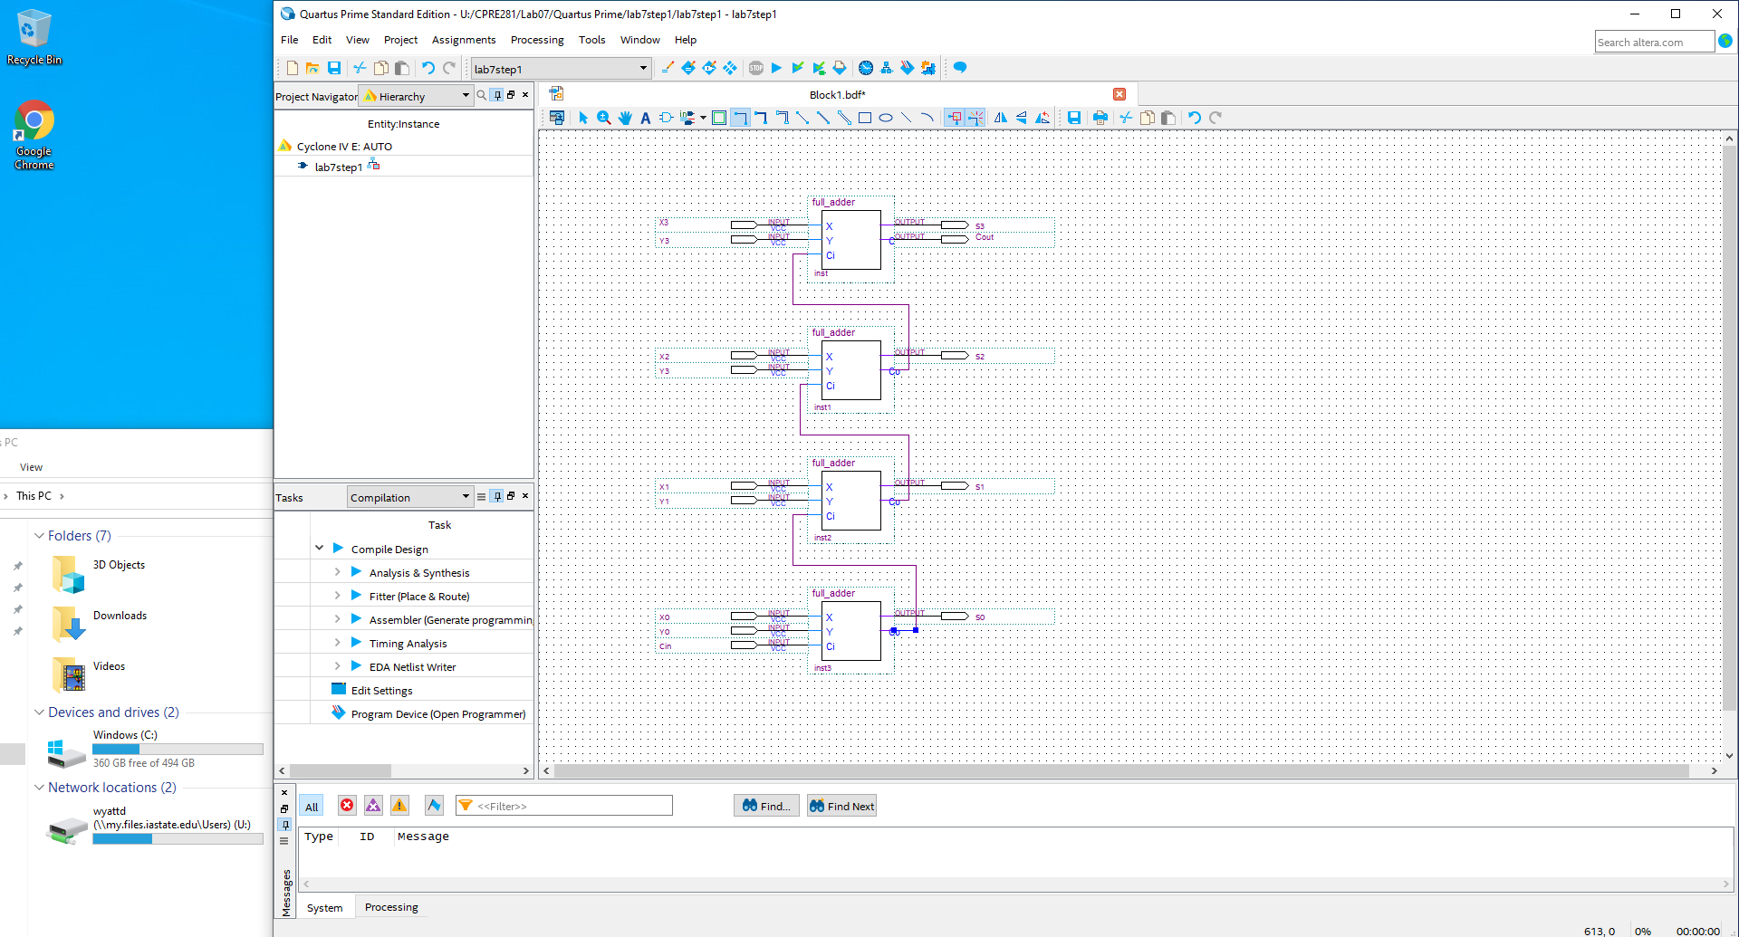

<<Insert a screenshot of your BDF file (add_sub.bdf) here>>

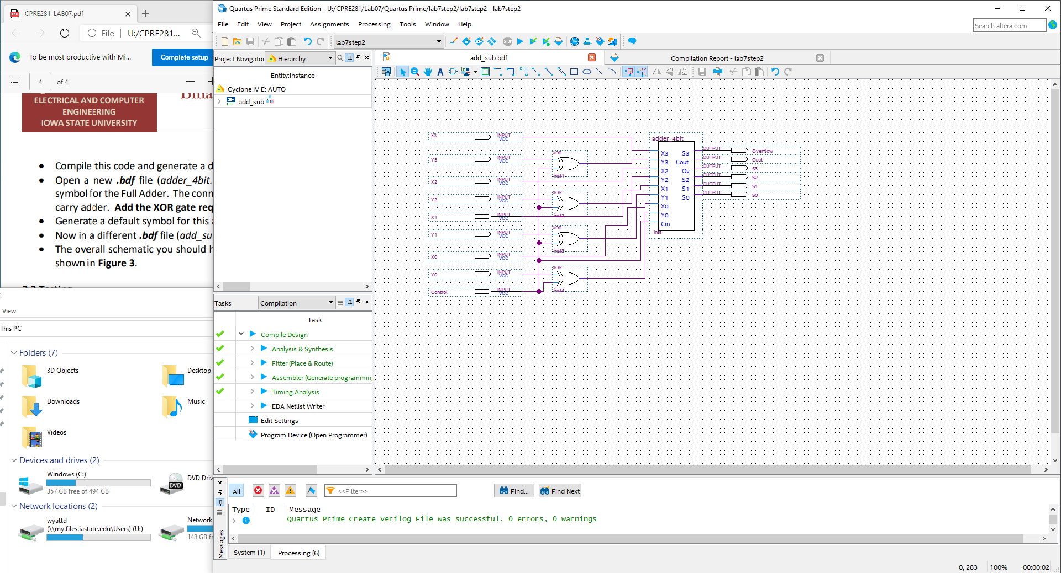

<<Insert a screenshot or copy your DO file here>>

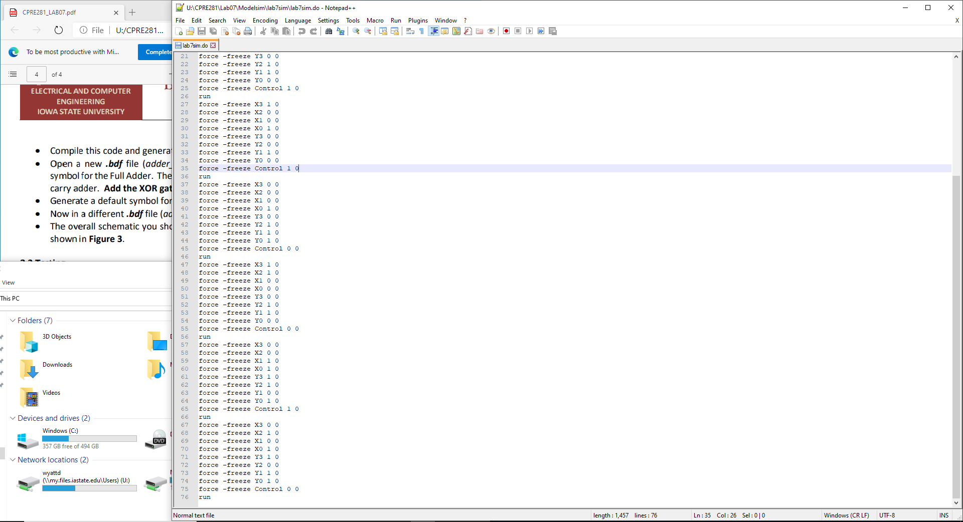

<<< Insert a screenshot of your DO file waveform>>>

